Relationship between *l b n* should be

lg d = 0.5 \* l \* lg n

Test Result:

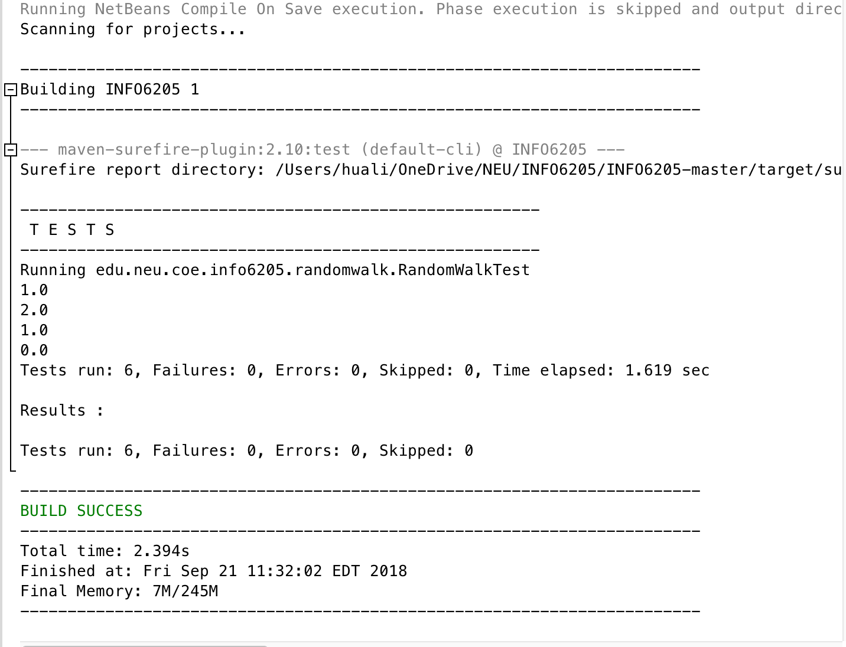

0 steps: 0.0

1 steps: 1.0

2 steps: 1.373773447853214

3 steps: 1.6120226591665963

4 steps: 1.920345939135507

5 steps: 2.3459375485823695

6 steps: 2.111328394722988

7 steps: 2.3864768102744573

8 steps: 2.0433720858531026

9 steps: 2.737212370545897

10 steps: 3.0400477700377015

11 steps: 3.3559059824358184

12 steps: 3.6109609140752204

13 steps: 2.998424808972688

14 steps: 3.405510427618872

15 steps: 3.710474379411347

16 steps: 3.4258039121707595

17 steps: 3.425984301896816

18 steps: 4.134909298502509

19 steps: 3.9050456346077222

20 steps: 4.152828715309297

21 steps: 4.55460612587896

22 steps: 3.837014538700838

23 steps: 5.1903013872151185

24 steps: 4.722849927142224

25 steps: 4.269142745065419

26 steps: 4.768674435311049

27 steps: 4.3085093749212895

28 steps: 5.483940379110366

29 steps: 4.969565189098409

30 steps: 4.851836727085043

31 steps: 3.9128433774377753

32 steps: 5.313173794875115

33 steps: 4.750463625136311

34 steps: 5.254377238261439

35 steps: 4.270378828938956

36 steps: 5.660719900136982

37 steps: 5.162696727495683

38 steps: 5.377585120183066

39 steps: 6.054805070277425

40 steps: 5.171216162134251

41 steps: 5.484379062041394

42 steps: 6.056900919180774

43 steps: 5.707429870402407

44 steps: 5.181242670652583

45 steps: 5.797988323695004

46 steps: 5.3481915802209254

47 steps: 5.692428398556829

48 steps: 6.442722838948716

49 steps: 7.1013001851522315

50 steps: 5.51279629548399

51 steps: 6.0015278458765895

52 steps: 5.771360967381175

53 steps: 6.067602526966479

54 steps: 5.52564610938073

55 steps: 6.2553795308689795

56 steps: 7.288756165636057

57 steps: 6.258349574747274

58 steps: 7.638211232686158

59 steps: 8.062949963208021

60 steps: 6.530345947483925

61 steps: 7.381742014361549

62 steps: 6.303617635123307

63 steps: 8.39238482286489

64 steps: 7.170807059363714

65 steps: 6.954238414804746

66 steps: 7.457793634057564

67 steps: 8.152305239503027

68 steps: 7.585689702138908

69 steps: 8.550745412079186

70 steps: 7.04806191150391

71 steps: 6.4503445223920695

72 steps: 7.5188798744653225

73 steps: 6.454723798707736

74 steps: 9.493854316019647

75 steps: 6.8561053431629

76 steps: 6.150017643760305

77 steps: 7.617155676626464

78 steps: 7.607741845127441

79 steps: 7.522075638984401

80 steps: 7.597610736716115

81 steps: 8.801751757195825

82 steps: 7.391400053503446

83 steps: 8.818847069379641

84 steps: 8.12315414782753

85 steps: 7.54867183998418

86 steps: 7.856350605783409

87 steps: 7.937646896149686

88 steps: 8.36832602184938

89 steps: 8.731958934596152

90 steps: 6.6995979812951765

91 steps: 8.600821742592538

92 steps: 8.19833022139048

93 steps: 8.167052711938329

94 steps: 7.951181344715819

95 steps: 9.044036203529158

96 steps: 8.731313745853294

97 steps: 9.442722857998037

98 steps: 7.468140037866202

99 steps: 7.204414011551235